**Project Documentation**

**Deployment Process**

**Prerequisites**

1. **System Requirements:** Ensure you have a system with the following:

* Python 3.8 or above
* Docker installed (optional for containerized deployment)
* pip (Python package manager)

1. **Libraries/Dependencies:**

* Install the required Python packages listed in the requirements.txt file using:

pip install -r requirements.txt

1. **Model Files:**

* Ensure the following model files are available in the project directory:
* linear_regression_model.pkl
* rfe_data_model.pkl

1. **Datasets:**

* Include the following datasets in the project directory:
* lasso_selected_data.csv
* rfe_selected_features.csv
* test.csv

**Deployment Steps**

**Option 1: Local Deployment**

1. **Clone the Repository:**

git clone <repository_url>

cd <repository_name>

1. **Run the Application:**

python app.py

This will start the server on http://127.0.0.1:5000 by default.

**Option 2: Dockerized Deployment**

1. **Build the Docker Image:**

docker build -t flask-regression-app.

1. **Run the Docker Container:**

docker run -p 5000:5000 flask-regression-app

Access the application at http://localhost:5000.

**Usage Instructions**

**Interacting with the Web Application**

1. **Access the Web App:** Open a browser and navigate to http://127.0.0.1:5000 or the appropriate Docker container address.
2. **Upload Dataset:**

* Use the upload feature to input datasets (e.g., test.csv).

1. **Run Predictions:**

* Click the "Predict" button to analyze the dataset.

1. **View Results:**

* View predictions and insights directly on the dashboard.

**Input:**

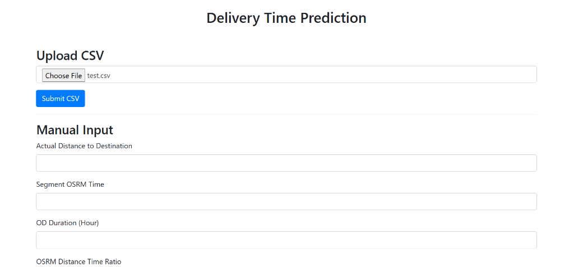

**Output:**

**The output will have the entered data with the data that has been predicted which here is the delivery time**

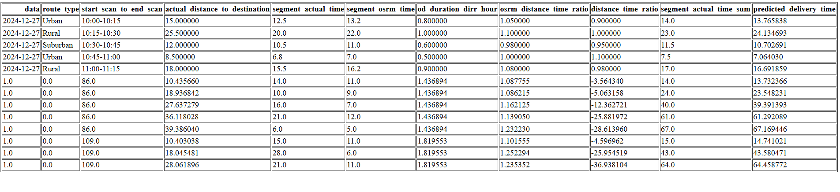

**API Details**

**Base URL**

* Local: http://127.0.0.1:5000
* Docker: <http://localhost:5000>

**Endpoints**

1. **/**

* **Method:** GET
* **Description:** Renders the homepage of the web application.

1. **/predict**

* **Method:** POST
* **Description:** Processes the uploaded dataset and returns predictions.
* **Payload:**

{

Json format data

}

* **Response:**

{

"predictions": [<list_of_predictions>]

}

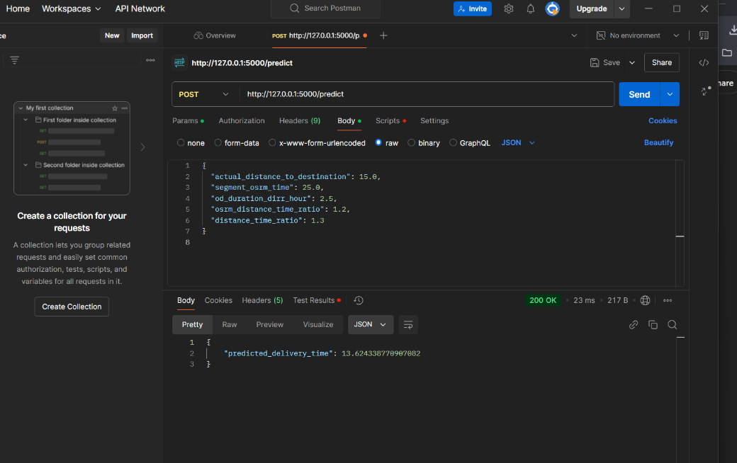

**User Guide**

**Steps for Interacting with the Web Application**

1. **Uploading a File:**

* Navigate to the "Upload" section.
* Browse and select a CSV file (e.g., test.csv).
* A person can input the prefered data manually.

1. **Submit for Prediction:**

* Click on the "Predict" button to initiate the analysis.

1. **View and Download Results:**

* Results are displayed in a table format on the dashboard.
* Use the "Download" button to save the results.

**Troubleshooting**

1. **Common Issues:**

* **Error:** Missing file or dataset.
* **Solution:** Ensure required files (e.g., linear_regression_model.pkl) are in the correct directory.
* **Error:** Dependency issues.
* **Solution:** Reinstall dependencies using pip install -r requirements.txt.